Fluid Flow Analysis of a Cooling Fan
By-Mehak Verma

1. Introduction
A cooling fan is used to generate airflow and remove heat from components by forcing air over the required region. The performance of a fan depends on parameters such as air velocity, pressure distribution, flow direction, and the geometry of the rotating blades.

2. Model Description
The model consists of a cooling fan with multiple blades mounted around a central hub. The fan geometry was used to represent the rotating component responsible for generating airflow.
A surrounding fluid region was considered around the fan so that the movement of air could be simulated. Appropriate inlet and outlet conditions were defined to allow air to enter and leave the computational domain.
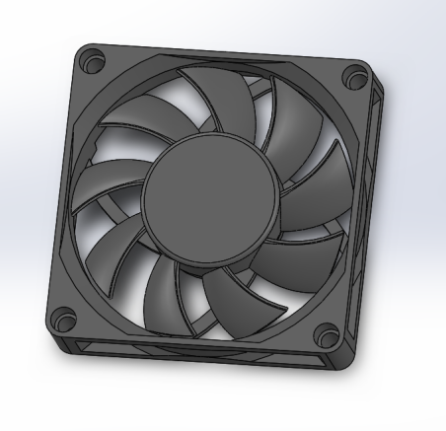

3. Simulation Workflow in Altair Inspire
After importing the assembly of the cooling fan as a step model . The fluid-flow analysis of the cooling fan was set up using the Fluid ribbon in Altair Inspire. The following workflow was followed:
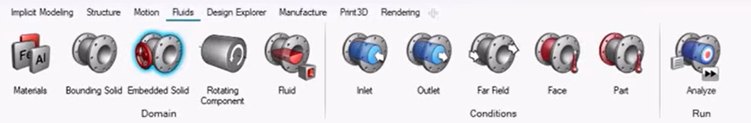
Step 1: Define the Bounding Solid
The Bounding Solid tool was used first to define the region in which the fluid would be contained. This solid represents the overall fluid domain surrounding the cooling fan and establishes the boundaries within which the airflow is analysed.
Step 2: Define the Embedded Solid
The Embedded Solid option was then used to define the solid component present within the fluid domain. The cooling fan geometry was specified as the solid component interacting with the surrounding fluid.
Step 3: Define the Rotating Component
The fan was defined as the Rotating Component, since the movement of the fan blades is responsible for generating the airflow.
The appropriate axis of rotation was selected so that the fan could rotate about its actual central axis.
Step 4: Assign Fluid Material
Air was selected as the fluid material for the analysis. The surrounding bounding region was therefore treated as the air domain through which the cooling fan generates flow.
Step 5: Apply Inlet and Outlet Conditions
The required inlet and outlet boundary conditions were applied to the fluid domain.
- The Inlet condition defines the location and conditions at which air enters the computational domain.
- The Outlet condition defines where the air leaves the domain.
These conditions establish the flow path through the cooling fan and allow the fluid solver to calculate the resulting flow field.

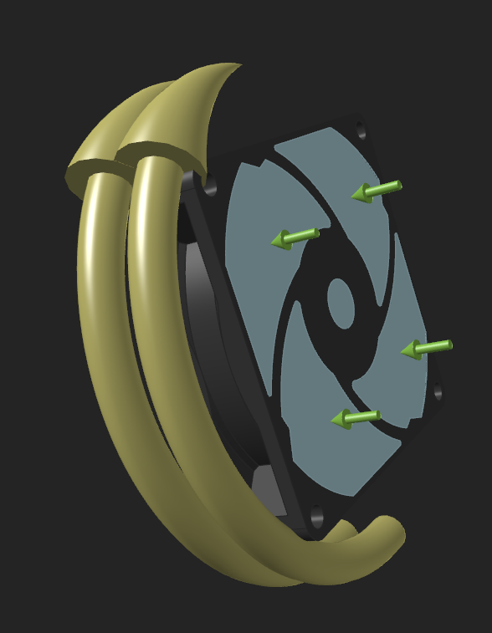
Step 6: Run the Fluid Analysis
After defining the bounding solid, embedded solid, rotating component, axis of rotation, air material, and inlet/outlet conditions, the fluid analysis was executed in Altair Inspire.
Step 7: Results Visualization and Interpretation
The resulting flow field was examined using the available post-processing tools. The velocity and pressure distributions around the rotating fan were analysed to understand how the fan blades influence the surrounding air.
The results were interpreted by observing the regions of increased velocity, pressure variation, and the overall direction of airflow generated by the rotating fan.
4.Results and Interpretation
The fluid-flow simulation of the cooling fan was evaluated using the convergence plots for average pressure and average velocity, along with the flow visualization around the rotating fan.
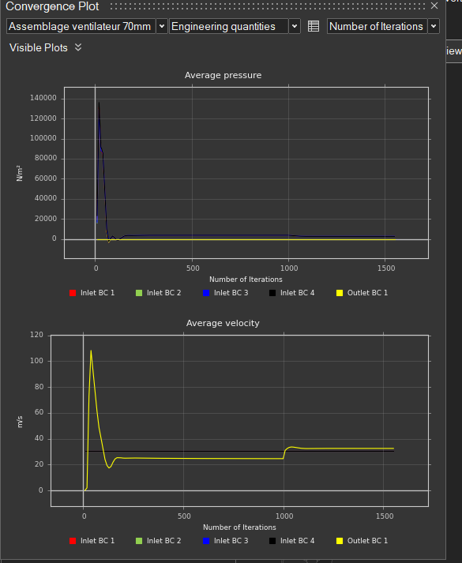
4.1 Average Pressure
The average pressure convergence plot shows a very high initial pressure value of approximately 135 kPa during the first few iterations. This is followed by a rapid decrease and a small transient undershoot.
After the initial transient, the average pressure settles to a relatively stable value of approximately 2–4 kPa and remains nearly constant for the majority of the iterations.
This behavior indicates that the solution undergoes a significant initial adjustment as the solver establishes the flow field. After this initial stage, the pressure solution becomes stable, showing that the pressure field has reached a converged or near-converged state.
4.2 Average Velocity
The average velocity plot shows a similar initial transient. During the early iterations, the velocity rapidly increases and reaches a peak of approximately 108 m/s. It then decreases and settles to approximately 24–25 m/s.
Around iteration 1000, a noticeable change occurs, after which the average velocity increases to approximately 32 m/s and subsequently remains nearly constant.
The final stable velocity of approximately 32 m/s indicates the established airflow produced by the rotating fan under the specified simulation conditions. The stabilization of the curve after the change suggests that the solution reaches a steady behavior toward the later iterations.

4.3 Flow Visualization
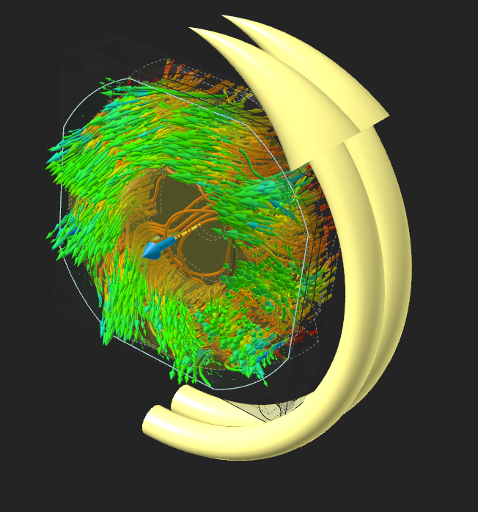
The flow visualization of the cooling fan shows the interaction between the rotating blades and the surrounding air. The fan blades transfer momentum to the fluid as they rotate, producing an airflow through the fluid domain.
The variation in the displayed field around the blades indicates that the flow properties are not uniform throughout the domain. The blade geometry and rotational motion influence the local flow behaviour, resulting in variations in pressure and velocity around the fan.

5.Overall Interpretation
The convergence plots show a strong transient response during the initial iterations, followed by stabilization of the flow variables. The average pressure settles to a relatively constant value, while the average velocity stabilizes at approximately 32 m/s toward the end of the simulation.
The results therefore indicate that the simulation successfully established a stable flow field around the rotating cooling fan. The convergence behavior can be used to confirm that the final results are more representative of the established operating condition than the initial high-pressure and high-velocity values.

